**Cancer Causing Genes : Their Coverage & Exome Analysis:**

a) **BRAF(proto-oncogene B-Raf and v-Raf murine sarcoma viral oncogene homolog B1) :**

One of the cancer causing genes , BRAF is a gene which makes the B-Raf protein in humans. Also known as serine/threonine-protein kinase B-Raf. Preliminary genome analysis:

Function : it is responsible for the cell growth by sending signals.

Gene : ENSG00000157764

Location : 14042943 – 140624564

Chromosome Name : 7

No Of Transcripts : 5

No Of Exons:

|  |  |
| --- | --- |
| Transcript 1: | 10 |
| Transcript 2: | 18 |
| Transcript 3: | 19 |
| Transcript 4: | 3 |
| Transcript 5: | 3 |

The largest Transcript is the Transcript 2 , with 2 480 bps.

The smallest Transcript is the Transcript 3 with 743 bps

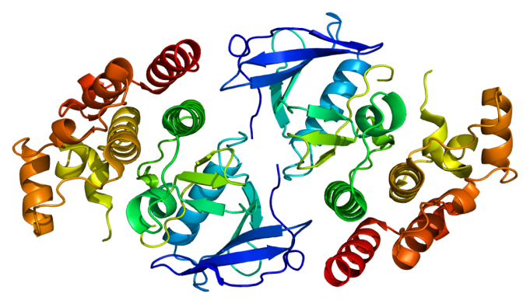

Fig 1 : The BRAF Protein

b) **MSGN1 :**

Called : Mesogenin 1

This is one of the genes, which has been **very less studied**. There are very few citations, even in NCBI.

Function: Involved in specifying the paraxial, but not dorsal, mesoderm. May regulate the expression of T-box

Transcription factors required for mesoderm formation and differentiation (By similarity)

Gene: ENSG00000151379

Location: 17997763 – 17997763

Chromosome Name : 2

No Of Transcripts: 1

No Of Exons: Transcript 1 :

|  |  |
| --- | --- |
| Transcript 1: | 1 |

There is only 1 transcript, which is 606 bps long with 193 residues.

c) **Tp53**

Called : **Cellular tumor antigen p53**

p53 is known as protein 53/ tumor protein 53 , which is a tumor suppressor gene which is encoded by Tp53 gene.

Function: It regulates cell cycle & is a tumor suppressor, which prevents cancer.

Gene : Ensg00000141510

Location : 7565097-7590856

Chromosome Name: 17

No Of Transcripts : 16

No Of Exons:

|  |  |
| --- | --- |
| Transcript 1: | 6 |
| Transcript 2: | 5 |
| Transcript 3: | 5 |
| Transcript 4: | 2 |
| Transcript 5: | 6 |
| Transcript 6: | 6 |
| Transcript 7: | 2 |
| Transcript 8: | 11 |
| Transcript 9: | 12 |
| Transcript 10: | 12 |
| Transcript 11: | 11 |
| Transcript 12: | 7 |
| Transcript 13: | 8 |
| Transcript 14: | 8 |
| Transcript 15: | 9 |
| Transcript 16: | 7 |

The largest Transcript is the Transcript 9, with 2653 bps.

The smallest Transcript is the Transcript 4 with 104 bps

Fig 2: Tp53

